Quick Start Guide

Get up & running in 1 hour

Welcome to [Agency Name]



We’re excited you’ve chosen us as your platform to listen to, understand and engage with customers. Elevate your business success with a flexible platform that focuses on data-driven results, all while saving you time.

Our “Quick Start Guide” will have you up and running in about an hour.

Setting Expectations

Let’s look at some baseline expectations:

1. Our platform makes customer feedback and online reviews easier. It will NOT take a business giving 2-star service and create 5-star reviews.
2. Our platform is the engine, but your customers are the “gas” to make it run. You must consistently add emails or mobile numbers to see growth.
3. Just like email marketing, only certain percentages of your customers will open your emails, texts or click a link.

Glossary

**1st-party review**: Customer comments, feedback, testimonials or any text given directly to you, the business.

**3rd-party review**: Customer comments written at online review sites like Google, Facebook, or Trip Advisor.

**Net Promoter Score (NPS)**: A business metric to help you measure your “word of mouth” growth for your business

Here is an average process to outline what you should work towards with our platform.

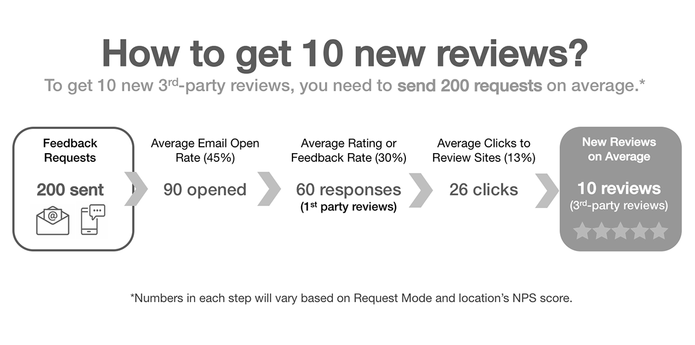

Get Started



1. **Verify Your Setup.**

Our Set-Up Wizard covered these steps when you created your account with us, but let’s take another look at each step to ensure your account is complete.

1. **Add Your Business Location.**

If you have multiple locations, you’ll need to create a business location for each profile. Each will have its own data and online review profiles.

1. **Add Your 3rd-Party Review Sites.**

Select which 3rd-party online review websites you want to direct customers to write a review on and which sites to monitor for new reviews. Try to select between 2 to 4 total.

1. **Authorize Google.**

Google is the most important review site for most businesses. Unlock key features when you authorize Google, such as in-app review responses, social sharing, and faster review monitoring.

1. **Brand Your Feedback Process.**

Make sure it has the look & feel of your organization, including accent colors and banner image.

1. **Choose a Request Mode.**

Pick from Ultimate Mode, Review Mode or Direct Mode to align with your goals. Customize your Feedback Settings and Rating Settings.

1. **Select Your Notification Settings.**

Basic settings are pre-checked, including Report Delivery and No Requests Sent Reminders. You can also receive notifications when requests haven’t been sent to alert you to any issues or lack of engagement.

1. **Add Customers.**

Upload a single customer manually, or upload a list in seconds. Utilize the Client Staff Form for easy customer uploads without needing a log in.

1. **Send Yourself a Test.**

Experience the processes just as your customer would to identify any gaps

You’re Up and Running, What’s Next?



Together, we’ve covered the basics. We are thrilled for you to dive in and explore all our solution has to offer when it comes to building long-term customer loyalty.

MUST-READ TIPS:

There are four big “review optimizations” you can make that will greatly impact your success on our platform.

1. **The “human ask.”**

Tell your customers in person you will be asking them for feedback and reviews. This creates a stronger responsibility on the customer’s end to respond and anticipate your request via email or text.

1. **Ask for feedback as close to purchase as possible.**

Add customers daily, weekly, or set up an automatic integration to add customer emails and/or phone numbers seamlessly.

1. **Install or embed the Review Widget on your website.**

Displaying your reviews will boost your SEO in Google search results, and act as social proof for website visitors which can improve conversions.

1. **Run a Smart Insights report.**

This AI-driven report will highlight what you’re doing well and where you can improve your business.

Our team is here to help. We’re dedicated to your experience with our platform, and are ready to help you make the most out of your customer feedback.